Chapter 7 Forces
extra worksheet 3: Forces produced by ice and steam
Science understanding Verbal/linguistic

Cracking ice
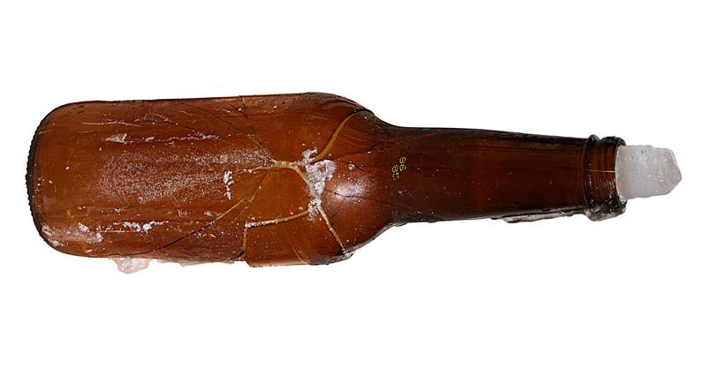
When water freezes, it expands by 9%.This expansion exerts a force on whatever is around the water. In this case, it was glass, which has shattered.
Solid gold metal sinks when dropped into a pot of liquid gold. This happens because as a liquid cools, the tiny particles that make it up move more slowly and usually pack together more closely. Being packed more tightly together, solid gold has greater density than liquid gold.
At temperatures below 4°C, when liquid water cools to form ice, something unusual happens. Instead of its particles being packed more closely, they become linked in a more open structure as ice crystals. As a result, the particles take up more space as ice than they do as water. The force of this expansion can crack rocks, burst water pipes and damage the foundations of buildings.

Full steam ahead!
As water particles are heated, they gain energy and break free of their liquid state. In becoming a gas, the particles move freely to fill the available space.
If this space is limited, pressure builds up as more steam is produced. Such pressure can exert a large force if it is suddenly released. Steam under pressure can make can make a saucepan lid jiggle up and down on a pot on the stove. On a larger scale, these forces can be used to power a steam engine, as shown below, or to turn the turbines of a power station.
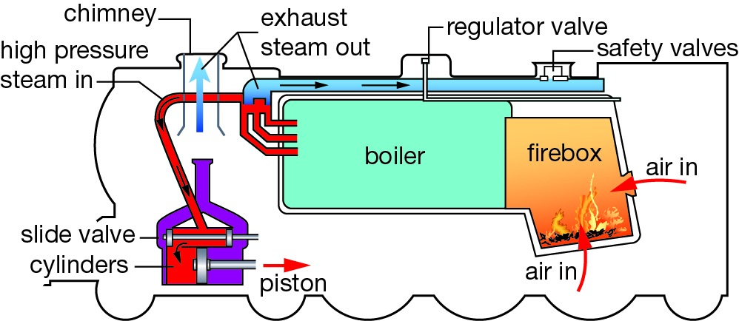
Water inside the boiler of the engine is heated to produce steam. Pressure builds inside the boiler and is released by a valve into the engine. The pressure of the steam pushes the piston in one direction. A valve slides across so that the next burst of steam pushes on the other side of the piston. This movement of the valve enables the flow of steam to push the piston back and forth. The piston is connected to the crankshaft, which turns the wheels of the locomotive.
1 State the percentage by which water expands when it is frozen.

2 Propose why the glass bottle shown in the illustration has cracked.

3 Explain why solid gold metal sinks in liquid gold, but ice does not sink in water.

4 When a person is exposed to very cold conditions, their extremities, such as the fingers and toes, and their face can develop frostbite. Propose how the freezing of water to form ice crystals in the skin can damage the body’s tissues.

5 State whether particles of a liquid gain or lose energy as they are heated.

6 In terms of the particle model, explain why gases spread out to fill the container in which they are held.

7 Recall three situations in which the pressure of steam can be used to apply a force.

8 Propose the purpose of the safety valve in the steam engine shown in the illustration.

9 Predict whether a steam engine would work if the steam was not kept under pressure. Justify your response.

